Experiment 40

VENDING MACHINE

AIM: To study and understand the formal design, specification and modelling of Vending Machine using Finite State Machine

FINITE STATE MACHINE (FSM) :
A Finite State Machine is an abstract model of a system (physical, biological, mechanical, electronic, or software. Key components of a FSM are
- A finite number of states which represent the internal “memory” of the system by implicitly storing information about what has happened before
- Transitions which represent the “response” of the system to its environment. Transitions depend upon the current state of the machine as well as the current input and often result in a change of state.

CONCEPTUAL MODEL OF THE VENDING MACHINE :

Vending machines (VM) are electronic devices used to provide different products such as snacks, coffee, tickets, etc. Vending machines provide several different types of items when money is inserted into it. The Vending machines are more practical, easy to use and accessible for user than the standard purchasing method. The efficient implementation of these machines can be in different ways by using microcontroller and FPGA board. They are designed to be able to accept money and serve product according to the amount of money inserted. The basic operation of VM is given below.
- The user inserts money and the money counter sends to the control unit, the amount of money inserted in the VM by the user.
- The operation buttons are active to choose the products that people like. According to the VM’s internal program, VM dispenses the products when people insert the correct amount.
- If the program is designed to return the change, VM will return the change.
- When selected product is not available, VM will reject the service.
FLOW CHART FOR THE OPERATION OF SODA VENDINGMACHINE :

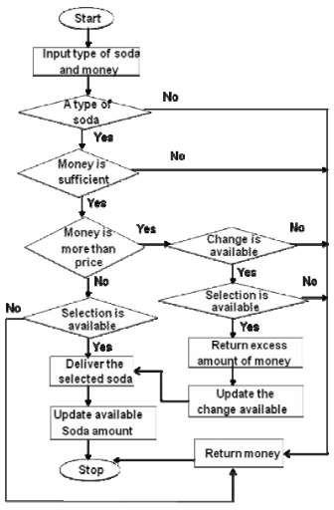
FORMAL DEFINITION OF THE FINITE AUTOMATA:

A DFA that describes the behaviour of a vending machine which accepts dollars and quarters and charges $1.25 per soda. Once the machine receives at least $1.25, corresponding to the final states, it will allow the user to select a soda. Self loops represent ignored input. The machine will not dispense a soda until at least $1.25 has been deposited and it will not accept more money once it has already received greater than or equal to $1.25.

Formal definition of the DFA can be written as D = (Q, 𝚺, δ, q0, F)
where
- Q → set of states {$0.00, $0.25, $0.50, $0.75, $1.00, $1.25, $1.50, $1.75, $2.00}
- 𝚺 → input alphabet {$0.25, $1.00, select}
- q0 → initial state. $0.00
- F → set of final states
- δ → transition function which is shown below as transition diagram

Transition Diagram :

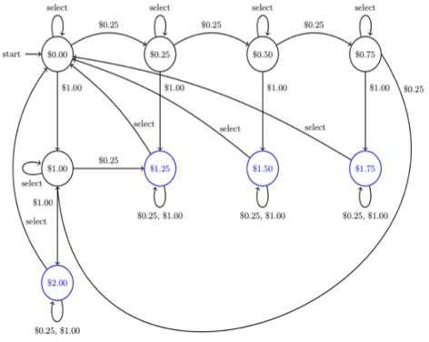
RESULT:

The conceptual model of the vending machine is studied using FSM automata theory. Constructing a FSM which uses fewer states enables the machine to provide fast response serving.

